SIMATS ENGINEERING
ASSESSMENT TOOL 1

COURSE NAME: Cryptography and Network Security
COURSE CODE: CSA5111

CONCEPT MAPPING

Code of Conduct:
I VANDHANA VARSHA.V (192524265)(Name / Reg No) certify that this submission is my original work and that I have adhered to the guidelines specified for this assessment. I understand that any violation of academic integrity rules will result in disciplinary action.

Signature of the student:V.VANDHANA VARSHA

Question 1: Security Attacks, Threats, Risks & Security Goals

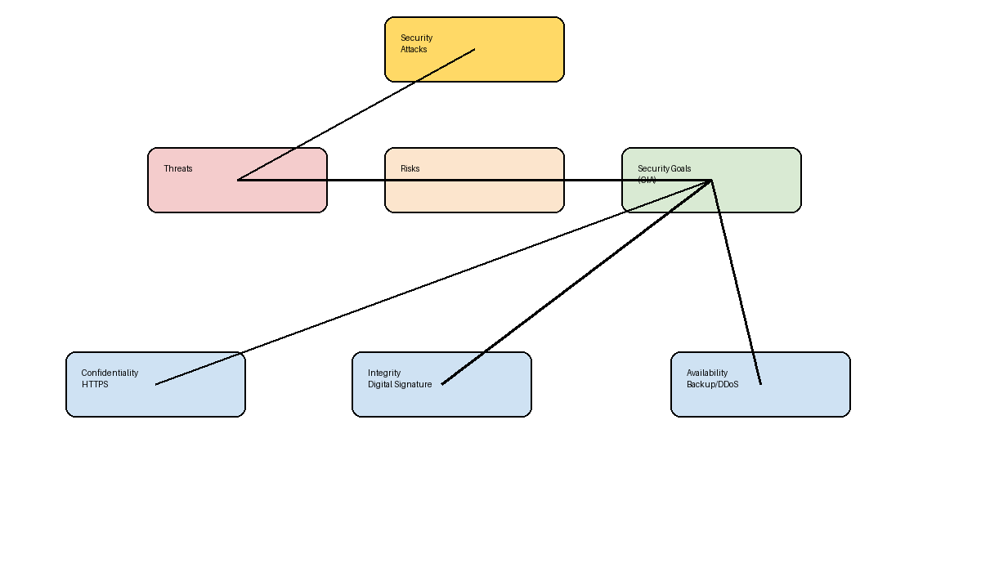
- (a) Attack → Threat → Risk: Malware → Unauthorized access → Data theft/financial loss.
- (b) CIA mitigates risks: Confidentiality (HTTPS), Integrity (Digital Signatures), Availability (Backups & DDoS protection).
- Examples: Phishing→Credential theft; SQL Injection→Database modification; DDoS→Service outage.

Question 5: Number Theory Concepts in Cryptography
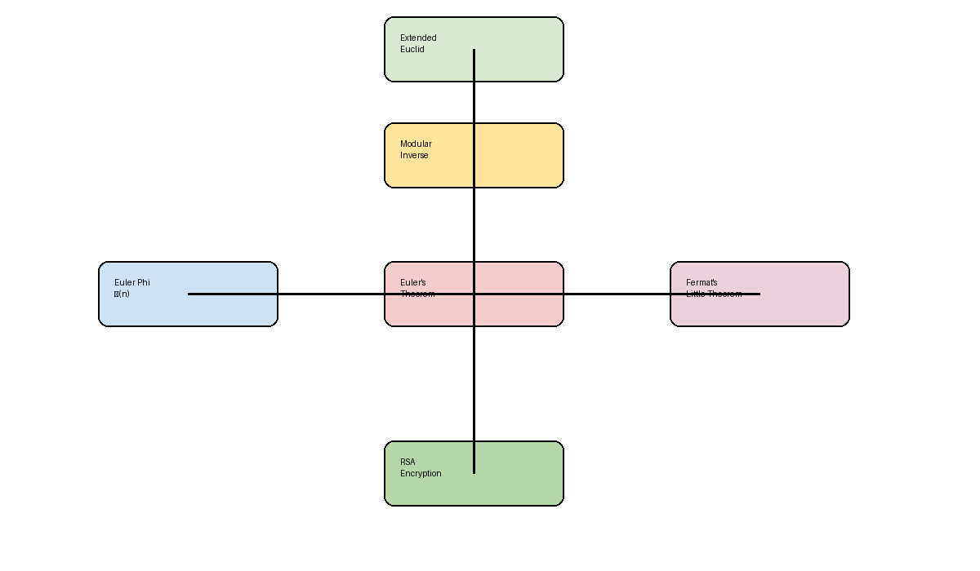
- (a) Extended Euclid computes the Modular Inverse. Euler's Phi Function is used in Euler's Theorem. Fermat's Little Theorem is a special case of Euler's Theorem.
- (b) Encryption/Decryption: Modular Inverse computes RSA private key; Euler's Phi and Euler's Theorem support RSA key generation; Fermat helps modular arithmetic and primality testing.
- (c) Most critical: Euler's Phi Function, because RSA key generation depends on φ(n) to derive secure key pairs.

